ICT – 31 (2026-2027)

JOB GETTING COURSE

31/10/2026 LinkedIn

28/10/2026 Cover letter. Feedback. The Benefits of Using LinkedIn

Vocabulary:
to get the ball rolling – to start an activity, project, or process, especially by taking the first step
relentless – continuing without stopping or becoming less intense/ невпинний / безперервний
novelty – новизна
Come rain or shine – whatever happens; regardless of difficulties or circumstances – за будь-яких обставин
to endorse – to publicly express support or approval for someone or something; to officially recommend a product, idea, or person – підтримувати / схвалювати / публічно рекомендувати
a roll-up-your-sleeves attitude – willing to work hard
tremendous – very good
eager to learn – want to learn

HOMEWORK:
- Learn new words
- Submit the final version of your resume
- Please share your feedback on Module 1: https://forms.gle/rVzhnjAjrj8dtcvp9
- Make a video of your pitch
- Teamwork: Benefits of using LinkedIn
Nastia N., Andriana, Mariana — Job Opportunities, Professional Networking

Denys, Nastia B., Yehor, Petro — Personal Branding, Career Growth & Development

Roman Sh., Vladyslav, Maksym — Visibility & Opportunity Creation, Professional Credibility
- Do a grammar exercise: https://www.listeninenglish.com/ve148-the-intern-video-resume.php
- Test: https://www.businessenglishsite.com/exercise_coverletter2.html

21/10/2026 Analysis of your résumés. Webinar: “The Power of You: How to stand out and get hired”

Vocabulary:
seasoned – experienced
to leverage keywords – to use them to achieve a maximum result
to forge positive relationships – to build and develop strong, friendly, and successful relationships, often through effort and cooperation
a sleek app – an application with a modern, attractive, stylish design that is usually simple and easy to use
adept at smth – very skilled or good at doing something, especially because of experience or natural ability

HOMEWORK:
- Learn new words
- Revise and improve your résumé, then submit the final version.
- Watch the video HOW to write a cover letter: https://www.youtube.com/watch?v=Wy1ywzSGa74 and answer the questions:
1. When do you need a cover letter?
2. Why might a cover letter be useful to you?
- How is it different from a résumé?
- What are the four tips for writing a perfect cover letter mentioned in the video?

USEFUL TIPS
SOFT SKILLS:
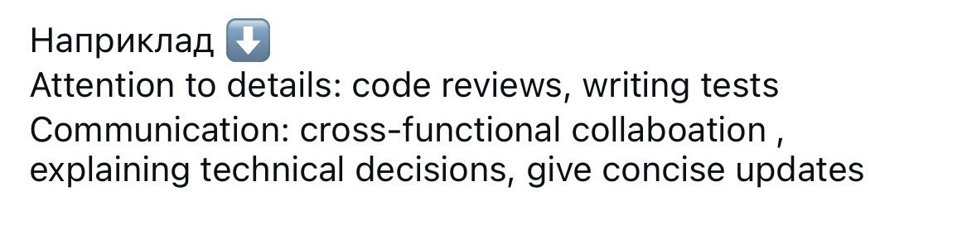

UNIQUE QUALITIES:

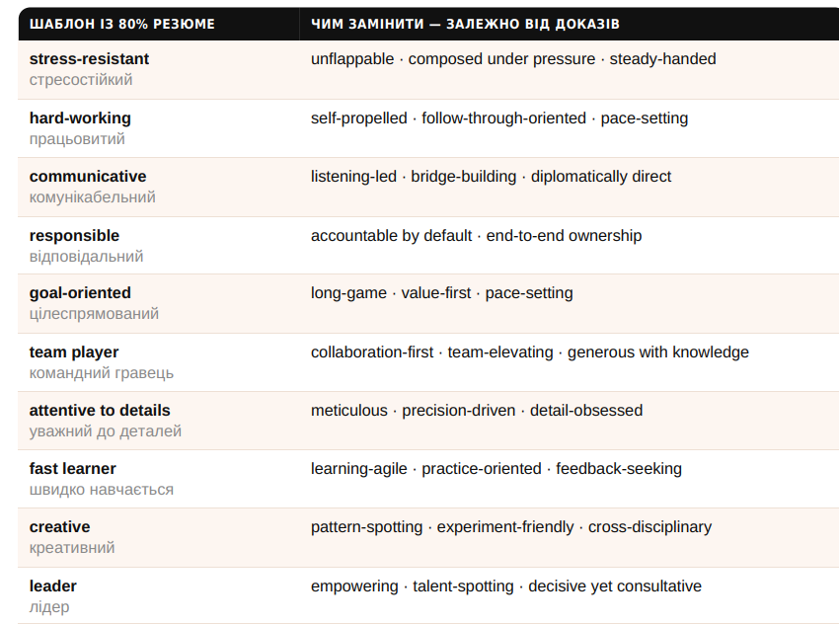
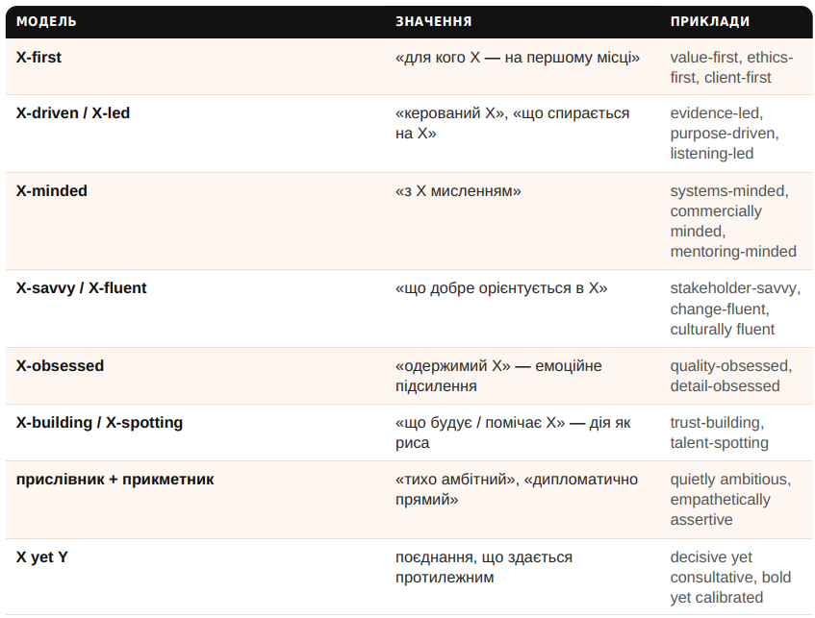
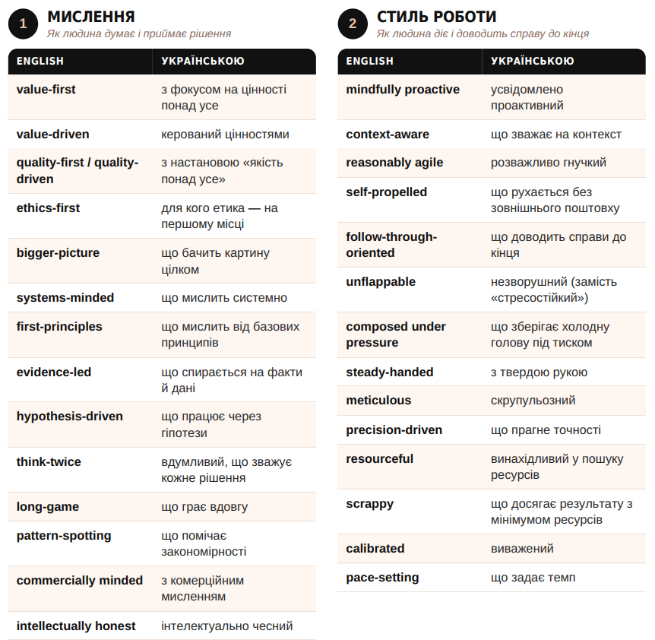
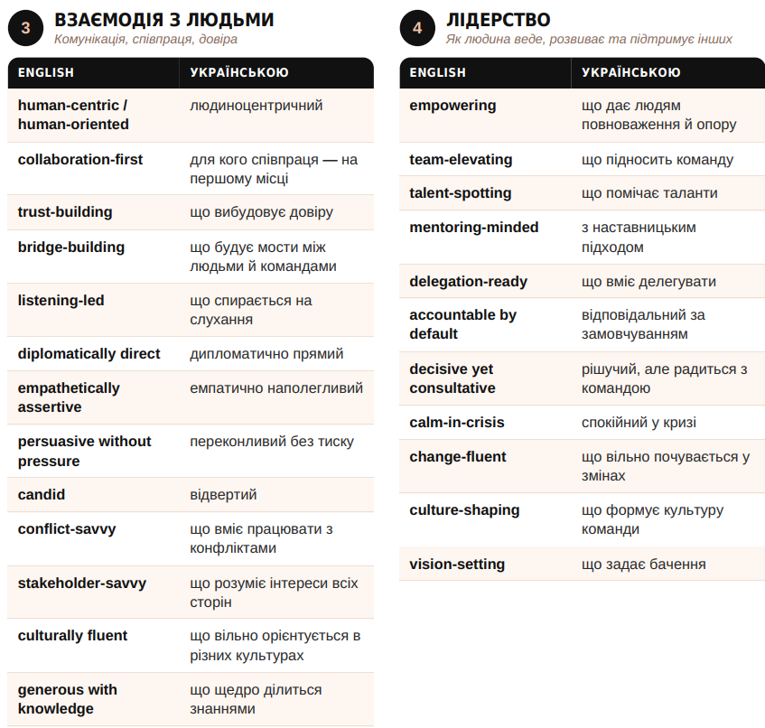

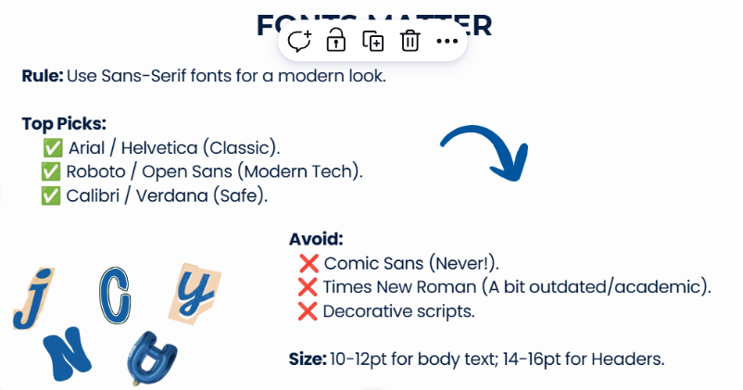
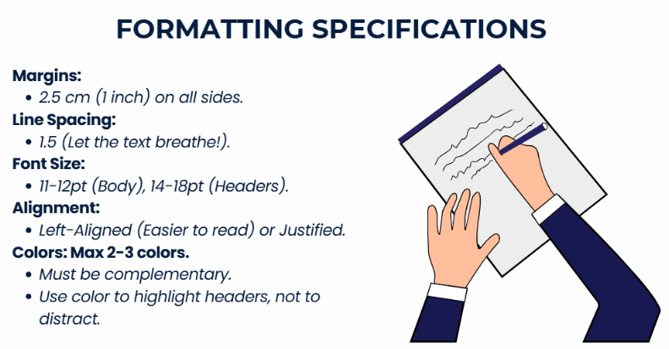

14/10/2026 Analysis of your resumes

ATS systems:
- https://www.jobscan.co/
- https://resumeworded.com/
- https://enhancv.com/resources/resume-checker/
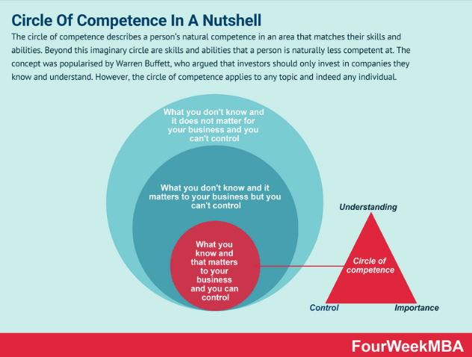

HOMEWORK:

- Watch the video: https://www.youtube.com/watch?v=0KHfRO2EnyA
- Please prepare your resume including the following sections and send it to me via Telegram:
Photo – a professional, high-quality image.
Contact Information – name, phone number, email, LinkedIn (if available), city+country.
Summary/Profile Statement (3–4 sentences)
Achievements, projects, certifications, education, and courses
Skills
Languages
Follow this formula to present your achievements:
Action verb (what you achieved) + what tool or technology did you use + result (how it improved some process) + quantify your achievement

07/10/2026 Achievements. Education.

In a nutshell – briefly

organised /ˈɔː.ɡən.aɪzd/ (BrE), /ˈɔːr.ɡən.aɪzd/ (AmE) – Cambridge pronunciation
creative /kriˈeɪ.tɪv/ – Cambridge pronunciation
successful /səkˈses.fəl/ – Cambridge pronunciation

HOMEWORK:

- Prepare a draft of your resume including the following sections:
Photo – a professional, high-quality image.
Contact Information – name, phone number, email, LinkedIn (if available), city+country.
Summary/Profile Statement (3–4 sentences)
Achievements, projects, certifications, education, and courses
Skills
Languages
Follow this formula to present your achievements:
Action verb (what you achieved) + what tool or technology did you use + result (how it improved some process) + quantify your achievement
- Do these tasks:

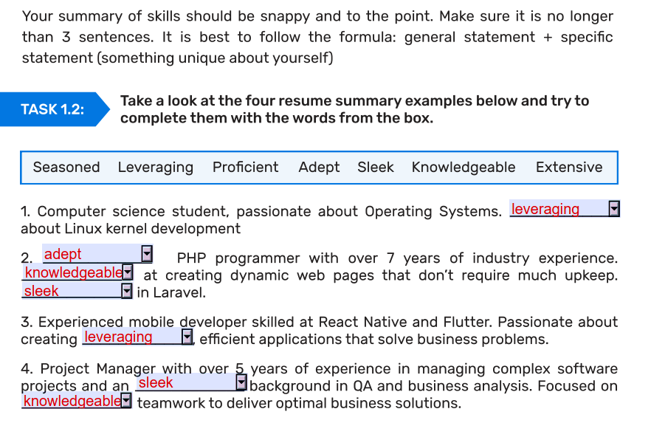
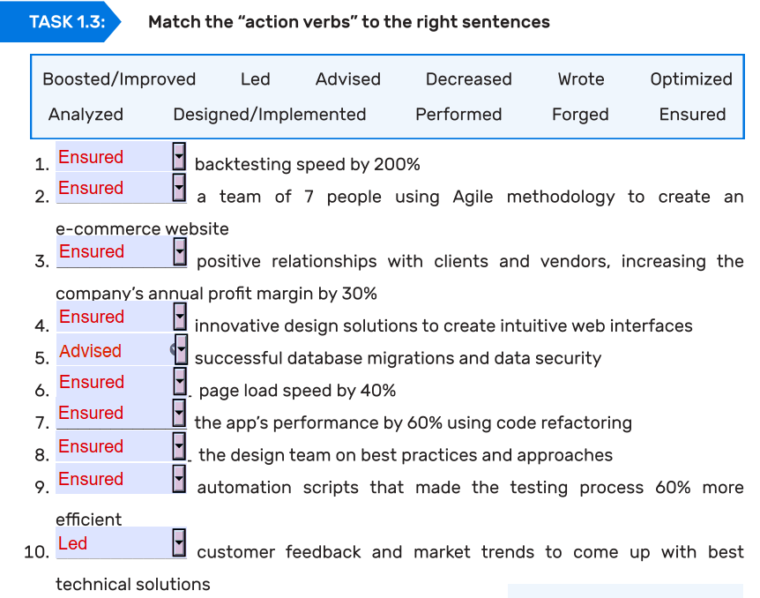

MORE EXAMPLES:
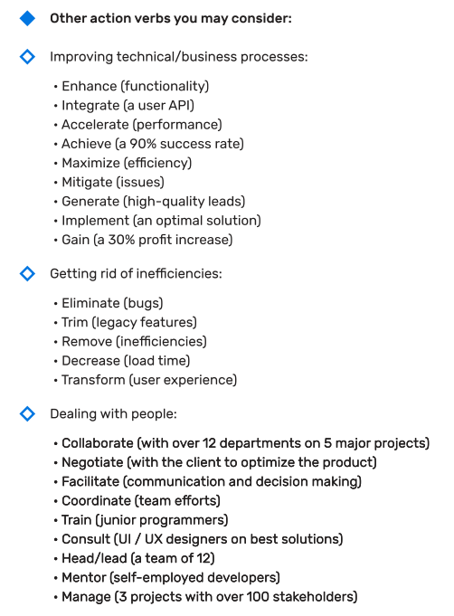

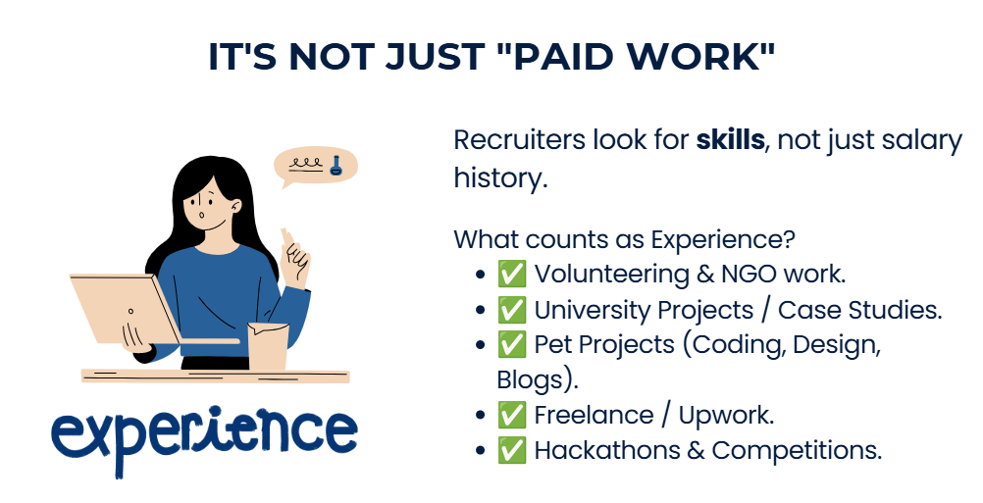

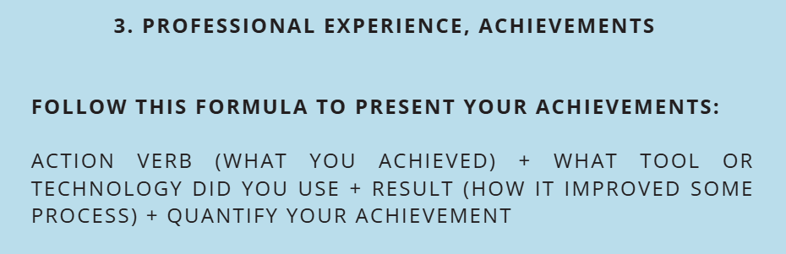
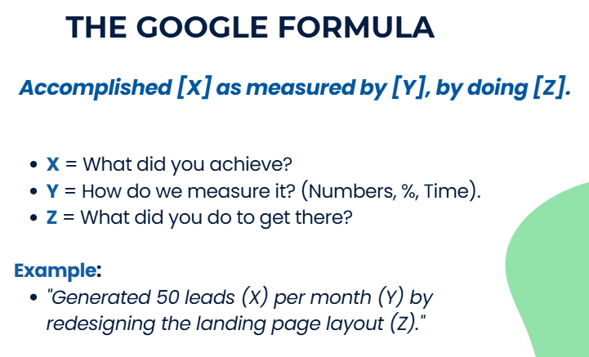

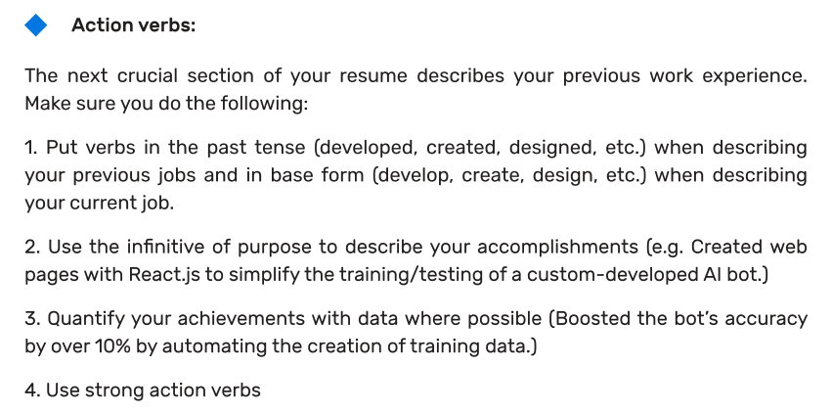

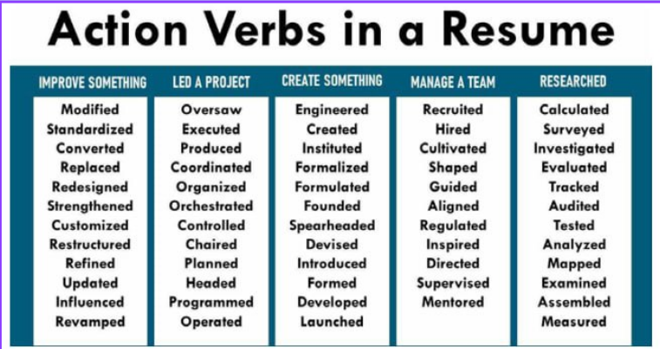

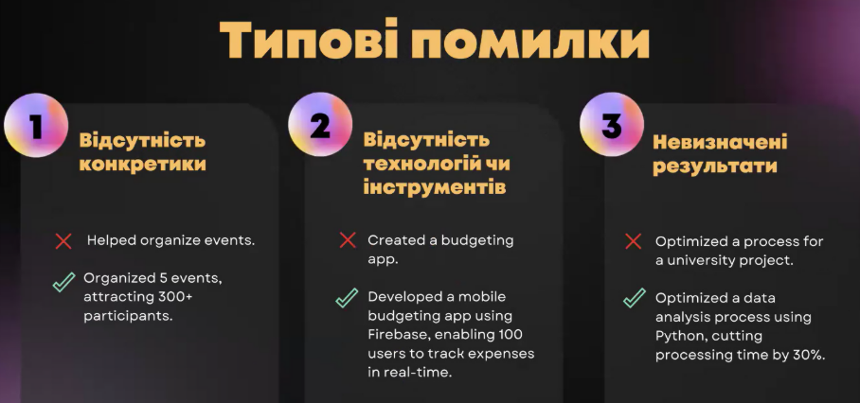
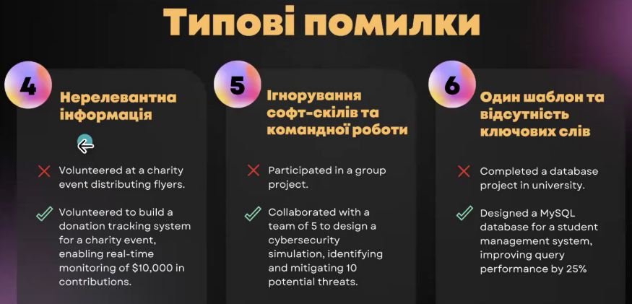

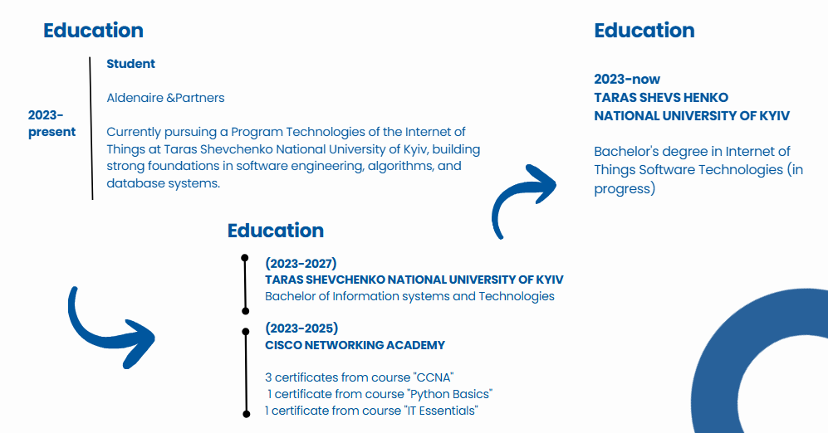

30/09/2026 TIPS for creating a killer resume

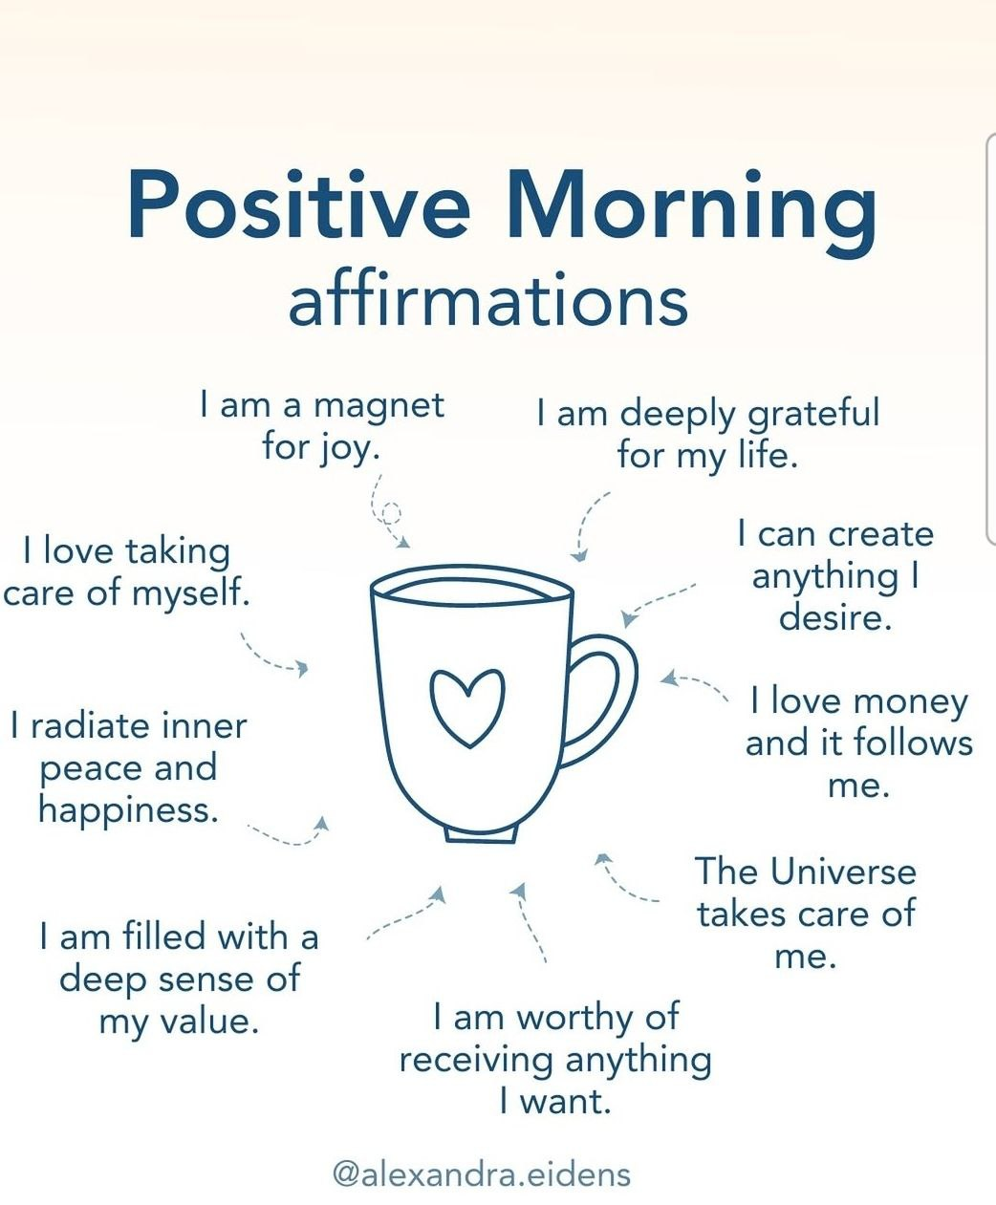

Vocabulary:
teething problems – temporary problems that happen when something new is starting or developing
business acumen – ділова хватка / ділове чуття
to take initiative – проявляти ініціативу
to leverage keywords – використовувати

Pronunciation:
accomplishment /əˈkʌm.plɪʃ.mənt/ https://dictionary.cambridge.org/dictionary/english/accomplishment
initiative /ɪˈnɪʃ.ə.tɪv/ – Cambridge pronunciation
accuracy /ˈæk.jə.rə.si/ – Cambridge pronunciation

HOMEWORK:
- Learn new words and prepare your pitch
- Prepare a resume template. Include the following sections:
Photo – a professional, high-quality image.
Contact Information – name, phone number, email, LinkedIn (if available), city+country.
Summary/Profile Statement (3–4 sentences)
- Watch the video How to prepare a resume for Google and share your insights: https://www.youtube.com/watch?v=BYUy1yvjHxE&t=403s
- Read the text 6 Tips for Creating a Killer Resume” and do these tasks:

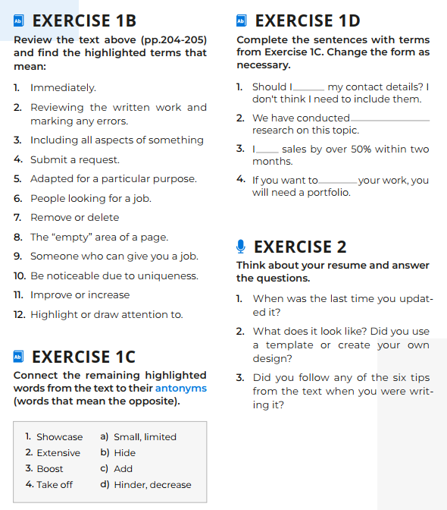

________________

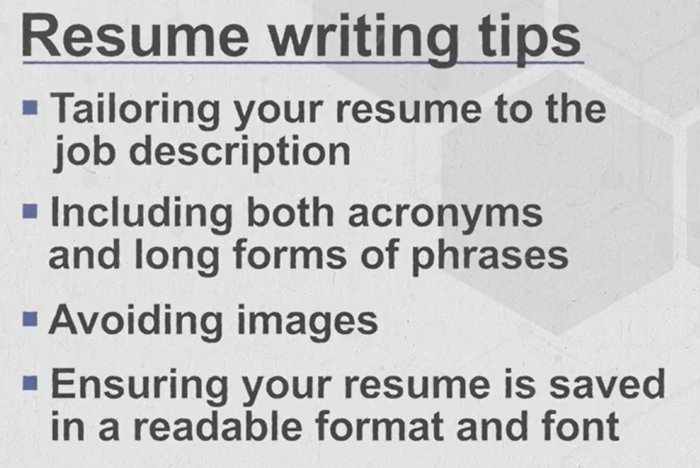

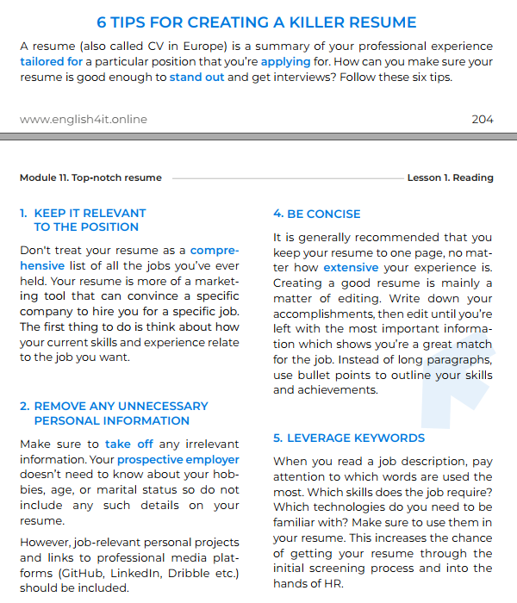
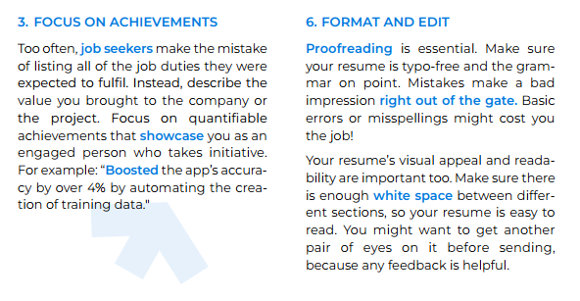

Profile
The profile (also called “summary” or “summary of qualifications”) section is a quick 3-4 sentence description of your key career highlights, experience, and strengths as a professional. Think about it as your sales pitch.
Your goal for this section is to give the prospective employer (= potential employer) a clear idea of what you do, what you’re good at, and why they should consider you for the position.
There are many ways to go about writing this section. Here is one structured framework you can use:
- Say who you are (state your position and level of experience)
- Describe your professional background
- Mention 1–2 key career achievements
- (optional) Showcase your soft skills by stating your motivation and professional qualities (This option is good for career switchers and people with no commercial experience)
For example: Goal-driven IT Manager with over 5 years of multinational corporate experience across multiple sectors. Skilled in driving digital transformation with a strategic vision and customer-centric approach, consistently achieving business growth milestones. Developed over 30 technology solutions contributing to the overall 75% boost in revenue for every client.
My students’ examples:
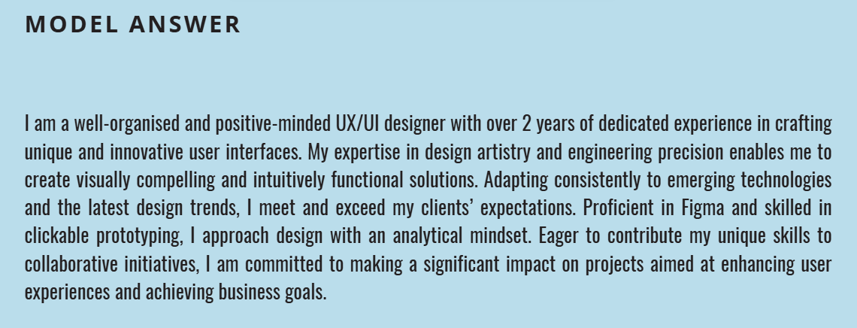

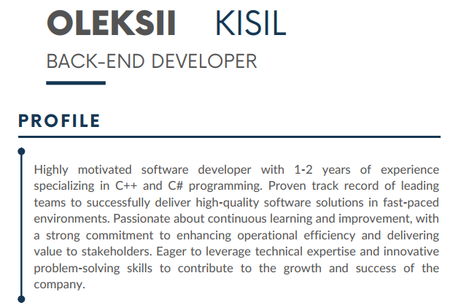
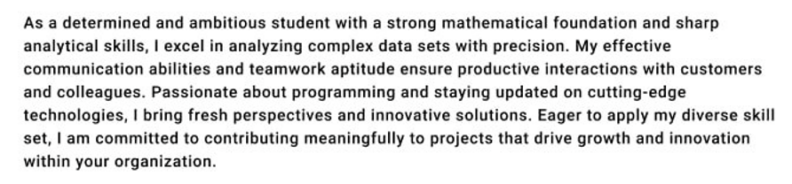

ATS – Applicant Tracking System: https://www.youtube.com/watch?v=8bSdDa_2H1w

26/09/2026 Interesting facts about resume writing. Resume structure

STRUCTURE of your RESUME

Photo: professional, high-quality image
Contacts: phone, email, professional social media, a city+country
Summary, profile: 4 sentences answering the following questions: Who are you? What can you offer? (your hard, soft skills, achievements) What can you bring to the company?
Hard/ soft skills – expertise – competencies
Working experience
Languages
Certificates / awards
Educational background: uni, courses

concise – brief
to thrive – to grow, develop, or be successful – процвітати; успішно розвиватися
a hands-on role – a job where you are directly involved in practical work – практична роль
to wear multiple hats – to have several different roles or responsibilities
vague – not clear or specific

HOMEWORK:
- Learn new words and prepare your pitch
- Watch the video: CV vs Resume: https://www.youtube.com/watch?v=UKKzWkbuS44
- Read the article and be ready to discuss it: https://www.linkedin.com/pulse/interesting-facts-resume-writing-what-you-need-know-stand-lewis-mxmke/
- Find and analyse relevant job vacancies and identify the requirements.
- Prepare a resume template. Include the following sections:
Photo – a professional, high-quality image.
Contact Information – name, phone number, email, LinkedIn (if available), city+country.
Summary/Profile Statement (3–4 sentences):
  - Who are you? (your background/field of study)
  - What can you offer? (key hard & soft skills, major achievements)
  - What value can you bring to the company? (how you contribute to their goals)
- Do these tasks:

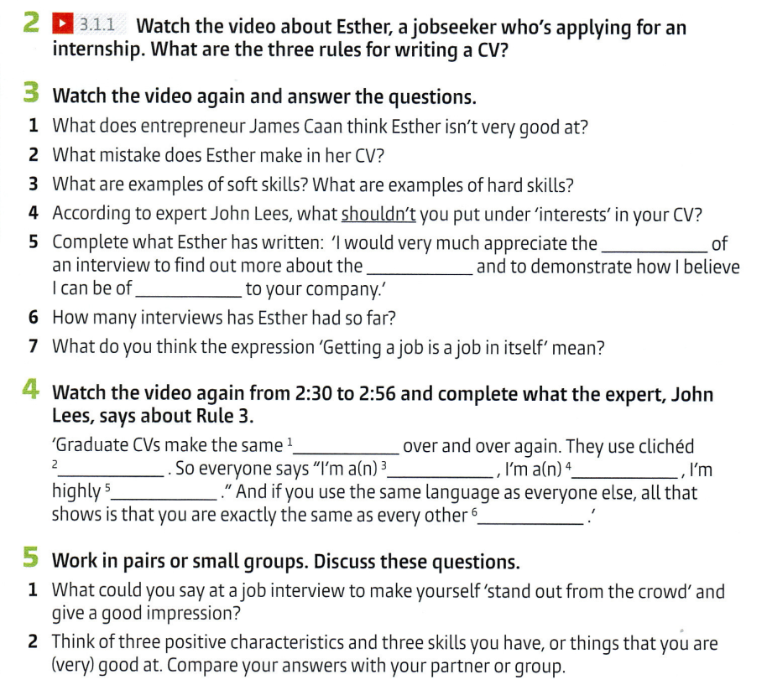

Platforms and tools where you can grab resume templates:

🎓 Student-Friendly Free Options
- Google Docs (built-in templates under “Template Gallery”) – simple and free.
- Microsoft Word (Office templates) – classic layouts, widely accepted.

Design-Oriented Tools
- Canva – modern, creative templates (great for students, easy to edit).
- Adobe Express – free resume templates with more design flexibility.
- Figma / FigJam Community – if you want customizable, stylish resumes.

Professional Resume Builders
- Zety – step-by-step builder, professional layouts.
- Novoresume – clean, ATS-friendly templates optimized for job applications.
- VisualCV – lets you create resumes + online portfolios.
- Kickresume – AI-assisted builder with templates and cover letters.
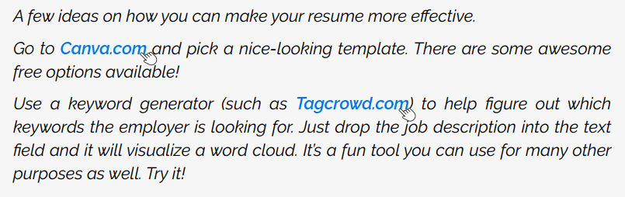

23/09/2026 Elevator pitch. Transferrable Skills

STEVE JOBS: You can’t connect the dots looking forward; you can only connect them looking backwards. So you have to trust that the dots will somehow connect in your future…

underlying strengths – базові сильні сторони
skills toolkit – набір навичок
to have a knack – мати хист / здібності до чогось
a seasoned specialist – досвідчений фахівець / професіонал

Pronunciation:
faculty – /ˈfæk.əl.ti/ – https://dictionary.cambridge.org/dictionary/english/faculty
Python – /ˈpaɪ.θən/ – https://dictionary.cambridge.org/dictionary/english/python
parliament – /ˈpɑː.lə.mənt/ – https://dictionary.cambridge.org/dictionary/english/parliament
architecture – /ˈɑː.kɪ.tek.tʃə/ – https://dictionary.cambridge.org/dictionary/english/architecture
event – /ɪˈvent/ – https://dictionary.cambridge.org/dictionary/english/event

My tip: create a Google Doc where you can collect all the information about the companies and vacancies you’re interested in, as well as your hard and soft skills.

HOMEWORK:
- Analyse the type of job you’re interested in and complete the following information:
Role:
Tasks:
Type:
Market: remote / local / international
Format: full-time / part-time / freelance / contract
- Find and analyse relevant job vacancies and identify the requirements.
- Prepare your pitch using the following structure:

PITCH:
- Self-introduction
Hello, My name is …
I’m … (job) with a passion for …/ a keen eye for detail
My experience spans (years), marked by achievements in (the field…)
With a keen focus on …. I’m well-equipped to (do some tasks)
I have over X years of experience in … (highlight your key experience)
2. Key skills
I’m proficient in
I demonstrated strong abilities in
Skilled in leveraging … (data architecture)
Known for my proficiency in …
Excellent at smth
Good/ great at … (working under pressure)
I’m experienced in … (web development)
I’m familiar with … (frontend frameworks)
I have a strong background in … (database management)
My key areas of expertise are … (data analysis and business analysis)

3. Achievements
Successfully led a team in …
Implemented a solution that resulted in …
Consistently exceeded performance targets, achieving …

4. Problems you can solve
I specialise in solving complex challenges related to (a field)
Experienced in …
Skilled at implementing solutions that directly impact (your company’s goals)
What can you do well? How can you help a company?

5. Call to action
Let’s explore how I can contribute to (some project)
I look forward to demonstrating how I can add value to your team.
Ready to bring my skills to (the company) and contribute to its success.

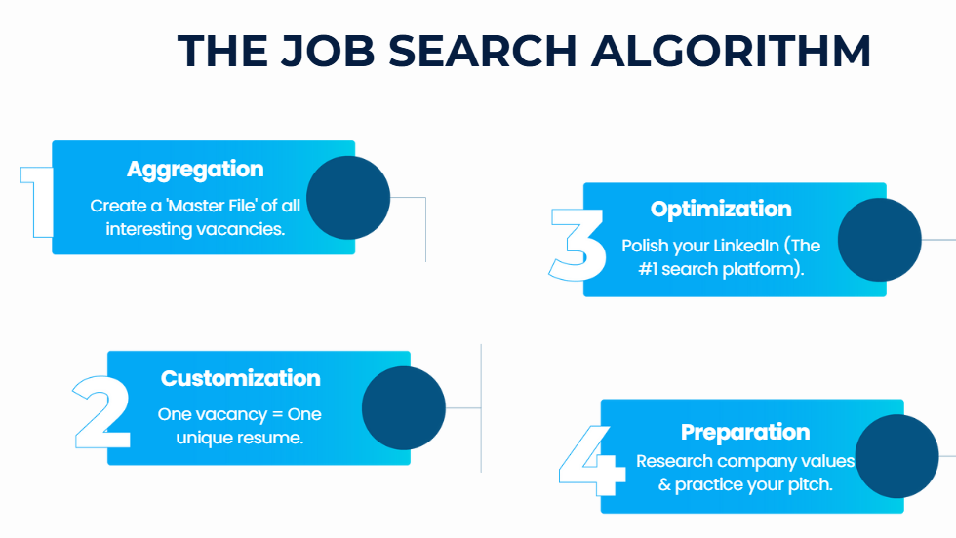
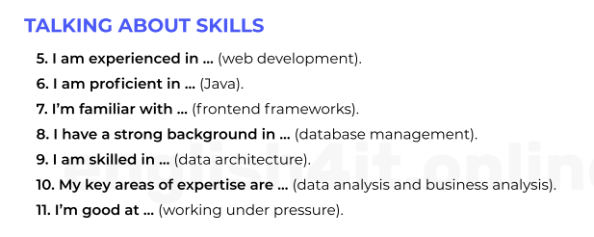

16/09/2026 Job hunting.


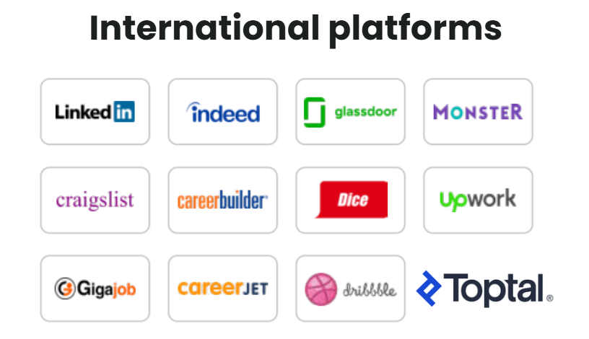

Vocabulary:
to sell yourself short – to devalue, underestimate your skills
top-notch service/ cafe/ specialist
to nail a job interview – to succeed in a job interview
nourish – живити, підживлювати, підтримувати
joint project – спільний проєкт
a hackathon
to increase – збільшувати(ся); зростати
to feel in one’s element – to feel comfortable, confident, and happy in a particular situation – почуватися у своїй стихії
to stand out from the crowd – to be noticeably different or better than other people – виділятися з-поміж інших
to think on one’s feet – to think and react quickly in a difficult or unexpected situation – швидко орієнтуватися; швидко приймати рішення

HOMEWORK:
- Learn new words
- Take a quiz: What is your tech personality, and take a screenshot of your description: https://www.codecademy.com/explore/sorting-quiz
- Watch the video and take notes of your takeaways: https://www.youtube.com/watch?app=desktop&v=xLzy3-CQIls&ab_channel=EnglishwithLucy
- Write your 3-4 Hard and 4 soft skills:

HARD SKILLS | SOFT SKILLS

09/09/2026 Job Search Basics for Young Professionals.

HOMEWORK:
- Watch the video and get career tips for young people: https://www.youtube.com/watch?v=SryD1az3sL4&t=4s&ab_channel=WGNNews
- Read and be ready to discuss: https://www.bbc.com/news/articles/cn9n9n5p9eqo
- Vocab exercises:



